Title of the forecasted paper
First Name LAST NAME (1), Author2 (2), Author3 (2), ….
1 - Affiliation, City, Country, email
2 - Affiliation, City, Country, email (author2), email (author3)

All abstracts for proposed papers regarding the Jicable'11 addressed topics should be submitted online before the deadline: 15 November, 2010.
The abstract should be :
- in English language, as a WORD 97 - 2003 file (.doc extension)
- adequately detailed
- present a synopsis of the paper emphasing any new ideas
- exposed in 500 words maximum, one single page as far as possible
- with title, author's names, their affiliations and emails.
The page layout must be :
- paper size A4,
- top margin 4cm,
- bottom, left and right margins 3 cm.
Arial font shall be used for the whole document. Font size is 10 pt by default but 14 pt for title paragraph and 110% characters spacing (title only).
Then list authors : first name LAST NAME (n) comma, next author. List the affiliations Company, city, country and email of each author. When listing authors with the same affiliation, don’t repeat the data regarding affiliation, but indicate both emails.
For the abstract body use Normal paragraph single line spacing, 6pt after.
- Numbered list

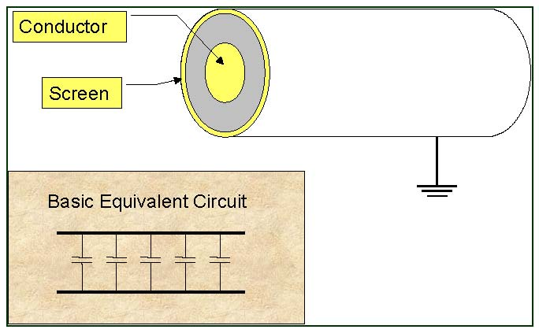
Fig. 1:.

- Numbered list
- Numbered list
- Numbered list
You may download some examples from the next link of the web page.

